Defining Business Process Management
Objectives
After completing this lesson, you will be able to:
- Comprehend the areas of business process management.
- Understand the advantages of business process management.
Business Process Management Overview
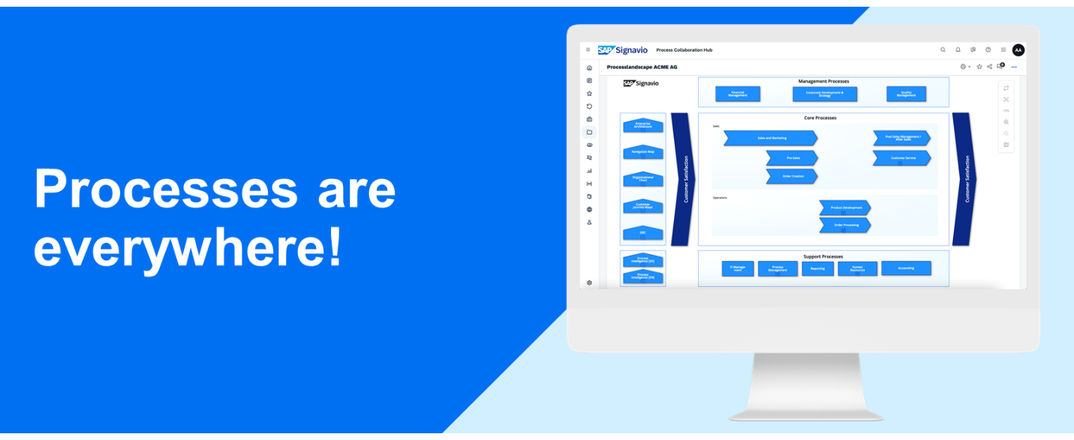
Processes Need Management - and Vice Versa
Processes are Everywhere, and We Can't Escape!
This sounds a bit like a nerdy horror scenario but there lies a truth in it. In fact, there is no company without business processes, and even we are part of processes every day. Either we are directly involved as a responsible participant or we trigger them in other companies as soon as we send a request, calling a support hotline or placing an order. For a company, a dedicated management of all these processes is crucial to react quickly to changes and ensure the efficiently of the business performance.
What is BPM?
If you asked a doctor, you would probably get the answer BPM stands for "(heart)Beats Per Minute". Although business process can also increase the (heart)beats per minute (especially if something went wrong), BPM is also the abbreviation for Business Process Management.
Managing Business Processes
Managing business processes require action and reflection, people, and their collaboration, as well as information technology or machines. Business process management is a systematic approach to consider all the different facets.
Goals of BPM
Business Process Management is an ongoing and iterative management discipline to:
- Capture relevant process information (e.g. through interviews)
- Design processes (visualize tasks, decisions and responsibilities)
- Execute processes (e.g. by systems or employees)
- Document processes (e.g. by creating a handbook)
- Measure processes (e.g. cycle times, costs, other KPIs)
- Monitor and control processes (e.g. automated and non-automated execution)
End-to-End Process Management
Business Process Management enables companies of all sizes and industries in applying a process-oriented management perspective on processes, but put them into an 'end-to-end' focus.
A comprehensive end-to-end process organization ensures that all operations in a business process work together in the best possible way and are optimized and aligned for the common purpose: meeting customer needs.
These processes range from the customer inquiry to the delivery of a product or the provision of a service. Such a process-centric focus helps to break departmental silos as end-to-end processes don't stop at department boundaries but requires the collaboration of different departments to accomplish the process goal.
Three-Level Focus of BPM (on processes)
Besides the process-centric focus on its end-to-end character, BPM also considers different levels to align and support processes in order to make sure it follows the companies' strategy on the one hand, and is also efficiently executed on the other hand.
3 Level Focus of BPMN
Technical Level:
- System support of business process management
- Many organizations rely on a professional process modeling software when designing their business processes
- BPM software can provide analytics and insights to process implementation
Operational Level:
- Dedicated to operational process models that deliver comprehensive insight into the specific processes in the organization
- Further refers to the execution of business processes by focusing on tasks and decisions by defined responsibilities
Strategic Level:
- Focus on the alignment and achievement of company goals.
- The level is important to ensure the company process and overall company strategy are always aligned. This makes it easier to decide on future investments and adapt to market change.
Overall Goal of BPM
The overall goal of business process management is to improve business performance. This can only be achieved by using a BPM software solution (e.g. SAP Signavio Process Manager), which provides features to structure, model, and analyze business processes.
Process Management Support
A good BPM software solution supports process management with:
- A central object repository for reusing the same business terms across all processes
- A (folder) structure to store and find processes
- A reporting functionality, which aggregates all information on selected processes
- A version control of processes if changes need to be reversed
- A diagram comparison (As-Is vs. To-Be comparison)
- Collaboration / commenting features to get feedback and collaborate on processes
- Functionality to capture additional information on processes and tasks, like risks & controls.
Business Process Management Advantages
In which business areas can a good BPM help?
Successfully applied, BPM can improve business operations and create a company-wide understanding of end-to-end processes. This leads to an increased transparency of those business operations, process comprehension and better and directed communication across departmental boundaries. There are three process-related areas, which are in focus for BPM.
BPM Business Area Applicability
Process Improvement
Not every process requires an immediate improvement - especially if it's related to a change of habits for people and their day-to-day tasks, which should be changed as rarely as possible. Improvements need to be evaluated and changes need to be planned and prepared.
BPM helps to:
- Identify pain points and tasks in a process that require improvement
- Identify the right stakeholders of a process and evaluate areas for improvements together
- Prepare the change / training for process participants
Process Transparency
Employees can only collaborate on processes and perform them, if they are documented and accessible. It is much more effective to document processes in a visual way to ensure all relevant information can be grasped at a glance. No one likes reading a lot of text in a Word document to figure out what needs to be done in case x. This is, where process modeling with BPMN 2.0 comes into play.
BPM helps to:
- Model and design processes in such a way, that all relevant information can be grasped at a glance
- Structure processes
- Provide a drill-down navigation from the value chain to the actual process for employee
In practice, very often a certain level of process transparency is even required for external certification (e.g. ISO 9000) or to prove compliance with risk management regulations for banks.
Process Implementation
For the implementation the business processes need to be transparently documented first. They are always performed in an end-to-end context.
BPM helps to:
- Implement processes into the company process structure (value chain)
- Publish them to all internal employees (in a process portal, like SAP Signavio Process Collaboration Hub
- Automate tasks / processes which have been done manually before
Benefits of BPM
If applied correctly, BPM provides huge benefits to companies.
Here are the top seven:
- Agility - The design of processes is quite flexible. Based on necessary changes to adjust to market needs, the impacted processes can be identified quickly due to a high process transparency.
- Productivity - Process improvements like removal of bottlenecks, parallel processing and elimination of redundant steps can be easily achieved with BPM.
- Efficiency & Reduced Risks - The visibility of processes allows focusing on inefficiencies. This includes also checking uncovered risks and controls on certain tasks in a process - and adding them where necessary.
- Compliance & Transparency - BPM ensures that organizations can implement regulatory requirements quickly. Compliance can be integrated easily into the process lifecycle, as visualized processes also reveal potential (or uncovered) risks.
- Employee Satisfaction - BPM allows employees to focus 100% on their work as process automation cuts down a lot of repetitive work and makes it easier to access information.
- Measurability - Due to its end-to-end process focus, processes can be compared to an expected result. This helps to streamline and quantify how well a process supports the operational business.
- Technology Integration - BPM software solutions bridge the gap between IT and business users, thanks to process modeling standards like BPMN 2.0. The focus is not only on integrating systems applications anymore, but equally on processes along with applications in order to accomplish the overall process goal.

